ETF

Subject:  Related Subjects: | Grade Level(s): 2,3,4,5,7  Length of Lesson: | Type: Inquiry / Design / Project  Keywords: Series circuit, current, LED

Lesson Overview
Use this section to describe at a high level what the lesson is. Should be no more than 3-4 lines.

Lesson Focus
What is the central question or phenomenon being investigated? What problem are they trying to solve?

Lesson Objective(s) | - Students will build an electronic board with six series open circuit combinations.  - Students will generate flash cards pairs of math problems.  - Students will use board to quiz each other on math concepts.

Lesson Timing

5 minutes | Introduce the Lesson
30 minutes | ...

Materials | - –Jumbo paper clips  - –LED  - –2 AA batteries  - –AA battery holder  - –Insulate wire  - –Index cards  - –Foam board  - –Masking tape  - –Wire strippers  - –Scissors  - –Xacto knife  - –Aluminum foil
Instructor Prep | - Step 1
Related Resources | - List related lessons/ppts etc available from USC or outside, trusted orgs

Lesson Plan

Introduction
Introduce students to the learning goals and make connections to past and present learning experiences. Stimulate interest and prompt students to identify their own questions about the topic. This can link the lesson to real world examples, introduce associated STEM careers, and assess their prior knowledge on the topic.

- Step 1

Procedure
Components and Parts

- –Cut 5”x 6” piece of foam or card board.
- – Cut 8 strips of aluminum foil
- –Cut and strip both ends of pieces of wire each 8”.
- –Strip the red and black wires from the battery holder

Construction

- –Poke hole with tip of pencil 1” from top of board.
- –From 2” below hole, place and attach six paper clips (so part is on top and bottom of board) equidistance apart on each side of board (figure 4).
- – Connect paper clips from one side to paper clips on other side using strips of aluminum foil (use any pattern). Place tape over areas in which aluminum foil strips come into contact with each other (figure 5).
- –Twist the red wire around the long leg of the LED and tape.
- –Twist one of the 8” wires around the other leg of the LED and tape.
- –Twist the black wire with the other 8” wire and tape (figure 6).
- –Tape the battery holder to the bottom of the board (the side with the aluminum foil strips.
- –From the bottom of the board, push the LED through the small hole and tape into place.
- –Bring the ends of the wires around to the front of the board.
- –Create 18 fraction problems with answers.
- –Create 18 decimal problems with answers.
- –Create 18 percent problems with answers.
- –Write math problems on small index cards and answers on separate cards.
- –Insert problem and answer under paper clips connected by foil strips.
- –Quiz your friends.

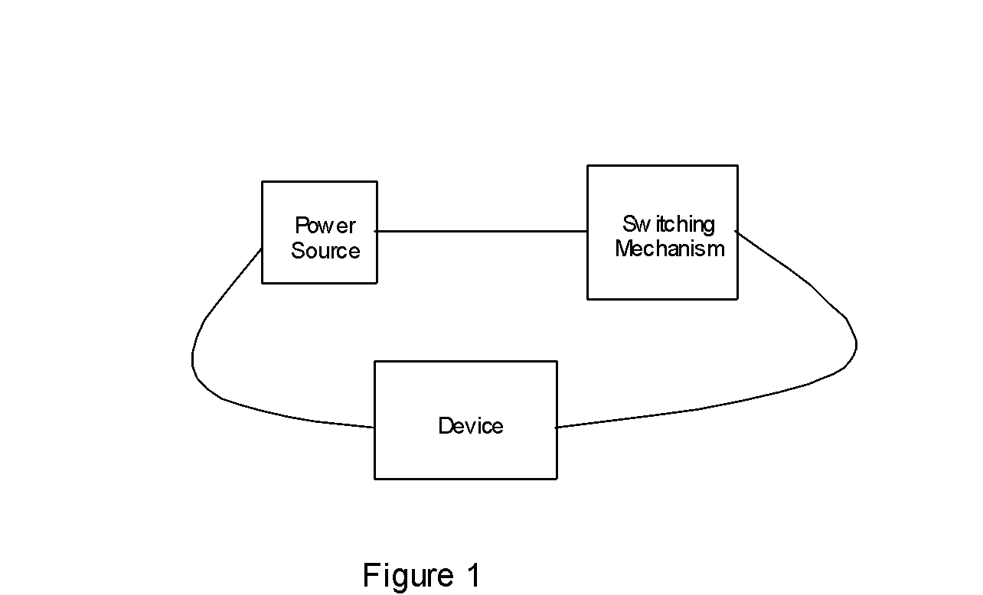
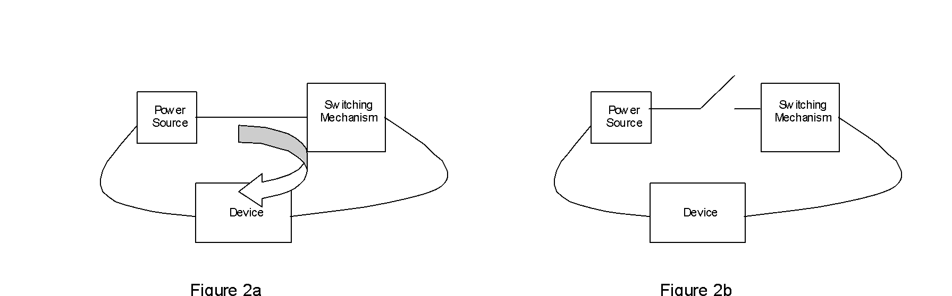
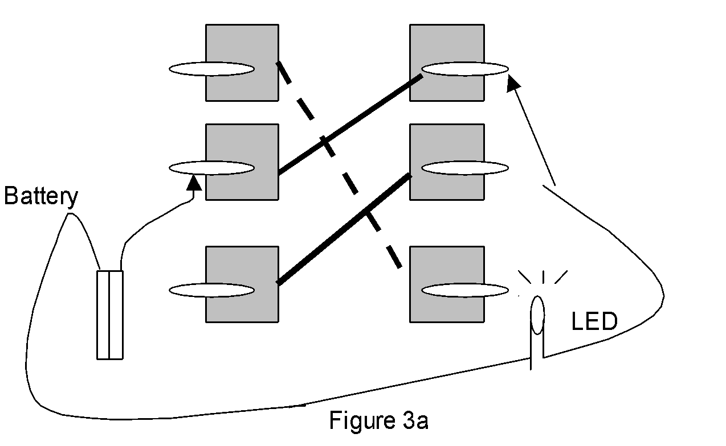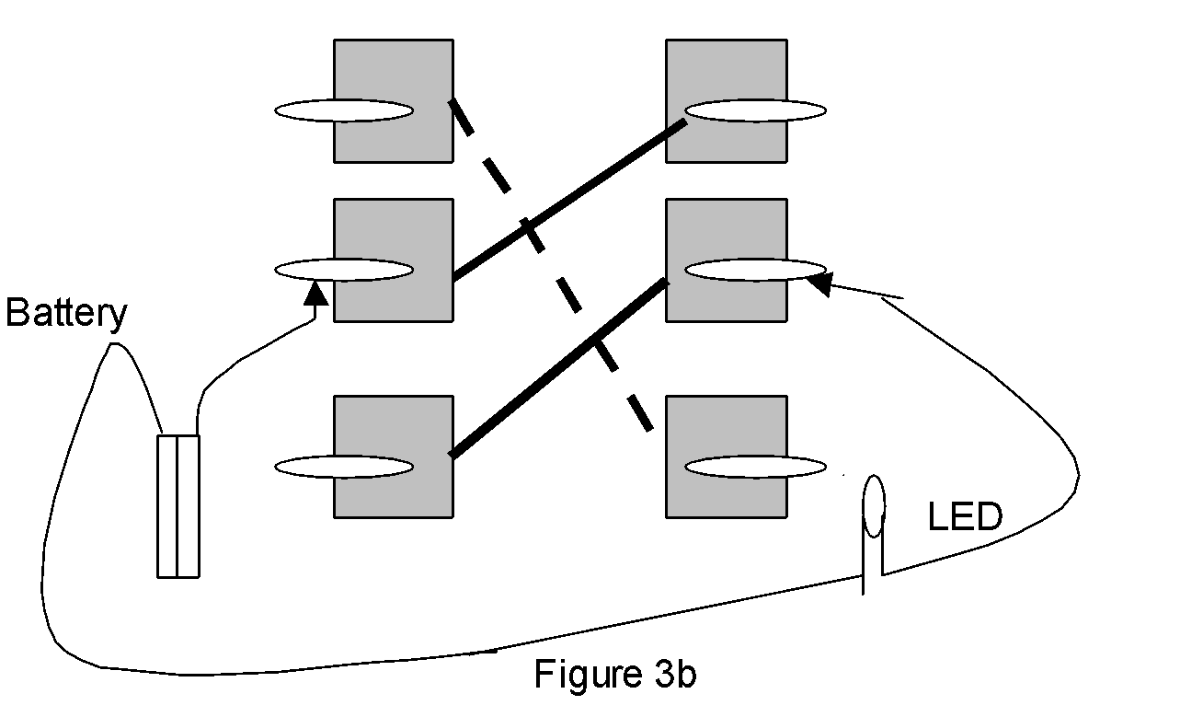
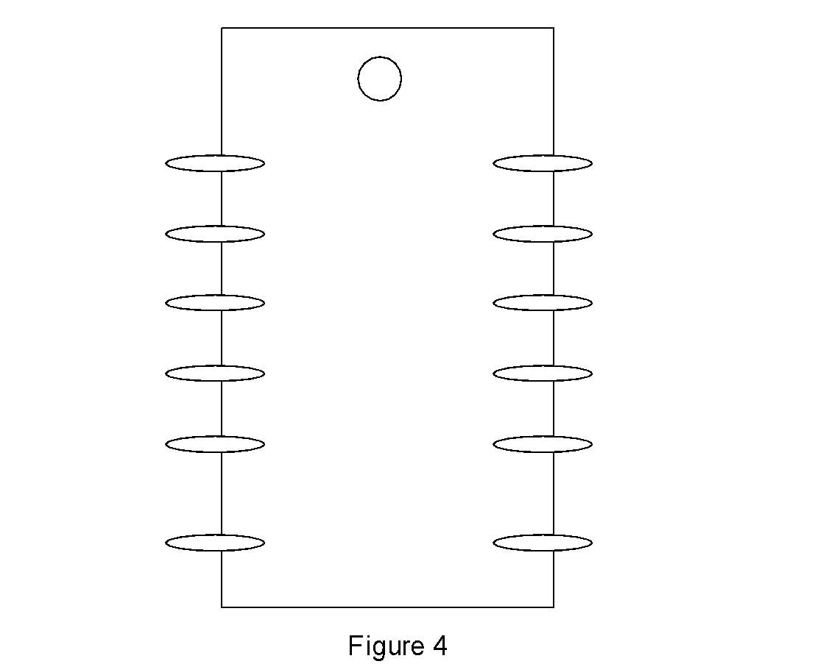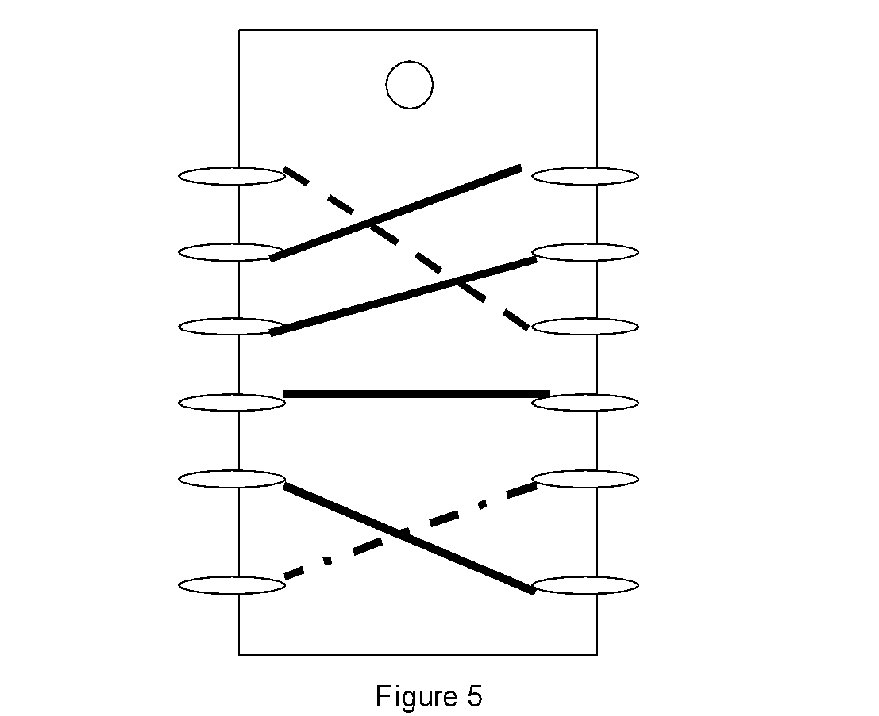
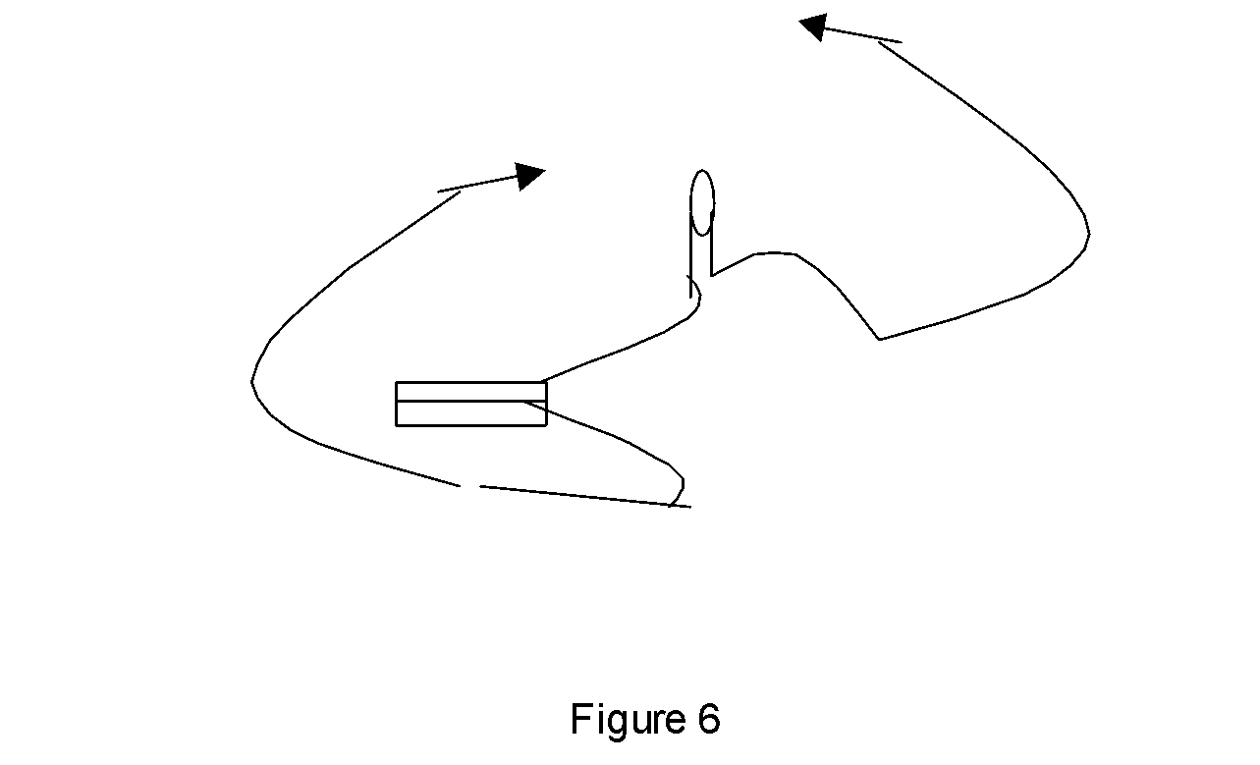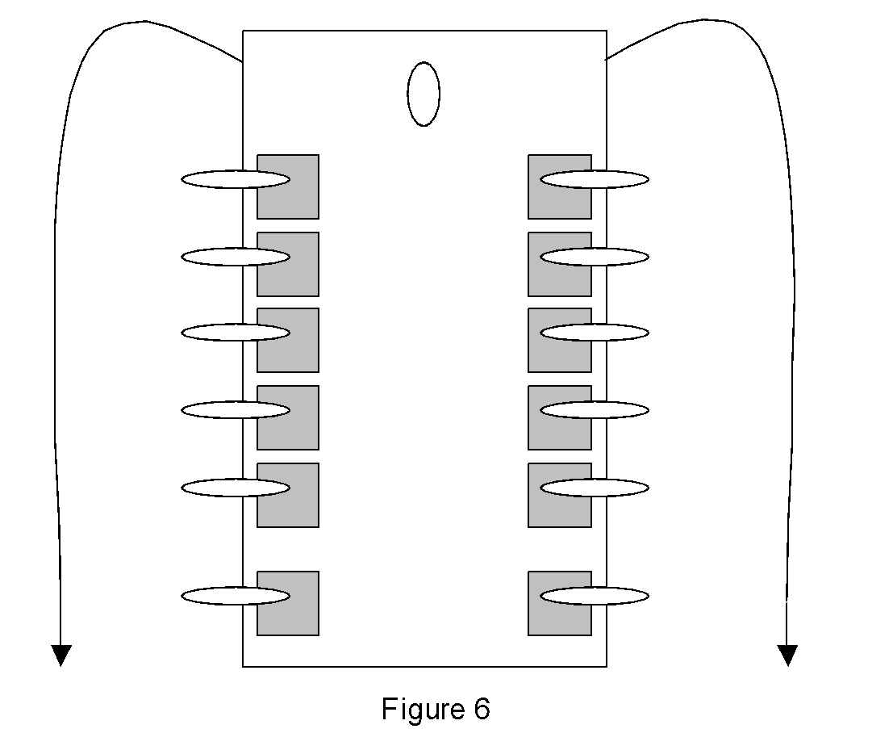

Troubleshooting
- Connect battery holder to LED to see if it lights up
- Check to make sure pieces of aluminum foil are not touching causing a short circuit
- Check wire connections make sure they are twisted together and not causing an open circuit

Wrap-up
End the lesson with some final discussions about what students designed/discovered. Connect their activity back to the focus question/problem, real world examples, and STEM careers.

Also include notes about any special cleanup considerations

Lesson Background for Teachers

Suggested Real-World STEM Connections
- List possible related Role Models in STEM (with details and links to more reading). Give suggestions for examples of scientists/engineers who are from underrepresented groups in STEM in related careers.
- List related real-world engineering problems and examples

Lesson Variations and Options
Include descriptions of alternative methods or ways to present things.

Explanation
Describe the background concepts and explanations behind the lesson. This can be more in depth than a teacher/instructor would actually share with students.

Key Concepts and Vocabulary
- Primary – A series circuit has a power source, a switch and a load where each one is connected to the other two.
- Secondary – Electricity only flows in a closed circuit. When there is a gap in a connection, the circuit is open.
- Tertiary – A short circuit means wires are touching that are not supposed to be. This gives the electricity a way around the intended circuit.

Safety Notes
- Safety instruction

